***Practical Class Module: Terrestrial Environmental Change 1***

**Introduction to Remotely Sensed Fire Datasets and the IPCC Greenhouse Gas Inventory Process**

# Introduction

The purpose of this exercise is to provide you with some initial practical experience of the sort of products that are obtained on vegetation fires and biomass burning from Earth orbiting satellites, and an overview of how these fit into the IPCC Greenhouse Gas (GHG) Inventory Process. Those of you who do the module in *Remote Sensing* next semester will gain a fuller understanding of how these products are produced, but this level of understanding is not necessarily required if you wish to use the products in inventory or other analysis procedures such as this. If you do not complete this practical work in class you should ensure you go back and finish the rest in the coming days.

**Learning objectives** are to gain an understanding of the process by which countries calculate and report their GHG emissions to the IPCC, and of some of the remotely sensed fire datasets that can be of use in these and other calculations.

# By the end of this practical you should:

* + Understand the basis of the IPPCC process for estimating GHG emission from vegetation fires, and be able to use the basic spreadsheets involved in this calculation.
  + Understand the basics of Active Fire and Burned Area datasets and how they are derived from remote sensing observations, appreciating their main advantages and disadvantages
  + Use the ENVI Image analysis system to;
    - Display image files
    - Display vector files
    - Perform simple mathematical operations on image datasets
  + Be able to search and order various fire datasets from online sources, such as the Fire Information for Resource Management System (FIRMS; [http://maps.geog.umd.edu/firms/).](http://maps.geog.umd.edu/firms/))
  + Be able to access and interrogate the ATSR World Fire Atlas (<http://wfaa-dat.esrin.esa.int/)> to view long-term nighttime active fire data collected by the ATSR series of sensors.

# Files

In your working directory, you are supplied with a number of files – these are:

**IPCC_GHG_LULUCF_merged.pdf –** the ***IPCC Good Practice Guidance Manual*** for estimating GHG Emissions from Land Use, Land-Use Change and Forestry. GHG emissions from open vegetation fires fall within this category.

**Anx_3A_1_Data_Tables.pdf** – Annex from the ***IPCC Good Practice Guidance Manual*** for estimating GHG Emissions from Land Use, Land-Use Change and Forestry. Page 3.179 – 3.181 provides information necessary for calculating GHG emissions from open vegetation fires.

**UNFCCC_Software_Manual.pdf** - the ***UNFCC GHG Inventory Software*** manual.

**3C1c_Biomass Burning GL.xls** - MS EXCEL file: Part of the UNCFF Inventory templates

**Greece_fires_aug09.kml** – burned area data of the 2007 Greek Fires

**200909021445.img** - this is a spectral subset of an image captured by the SEVIRI sensor onboard the geostationary Meteosat satellite that images Africa and Europe every 15 minutes. Some details on SEVIRI can be found here: <http://www.esa.int/msg/pag4.html>

**ModisBurnedArea_by_country_landuse_vegetation.xls** - MS EXCEL file recoding the area burned in African countries based on the MODIS “burned area” product (see below)

**MCD45A1.A2008214.h19v10.005.2008279131907.hdf** – a MODIS “burned area” MCD45

product file. This file is from year 2008, day of year 214 (which is 2nd August). This file contains the data from the tile h19v10 – which is located in Southern Africa, and mostly over Angola.

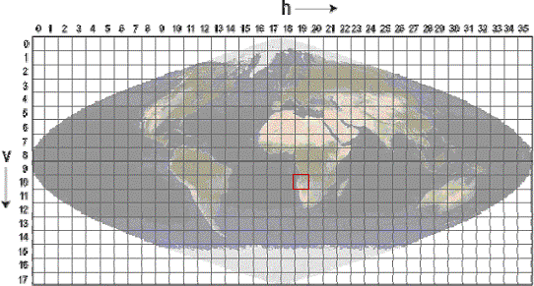

*Figure 1: Tile locations representing the coverage of the MODIS Land Data Products (h19v10 covers the region around Angola for example).*

# Practical Instructions

**3.1 The IPCC GHG Emissions Inventory Process**

Load the IPCC Good Practice Guidance Manual in a PDF reader (by clicking on it) and goto Chapter 3 (Section 3.48; page 95 Headed “**GREENHOUSE GAS EMISSIONS FROM BIOMASS BURNING”**. This section covers emissions from biomass burning activity in areas where the land use remains the same (e.g. burns in forest remaining as forest after the burn; e.g. burning for land management) and also areas where the land use is changed (e.g. forest being cleared to use as cropland; e.g. burning for land use conversion).

[Note LUCF stands for Land Use Change and Forestry].

You can see that Equation 3.2.20 essentially states that the IPCC recommends use of the “standard” emissions estimation procedure to estimate GHG emissions from these types of fire, which we covered in our lecture:

# Quantity of GHG released (Lfire) = Area Burnt (A) (Equation 1)

**x Available Fuel Mass (B)**

**x Fraction of Biomass Combusted (C)**

**x Emissions Factor of the GHG (D)**

Where

Lfire is expressed in tonnes A is expressed in ha

B is expressed in kg of dry matter per ha

C is expressed as a unitless value from 0.0 to 1.0

D is expressed as grammes of the GHG released per kg of dry matter burned

[Note the IPCC call factor C the Combustion Efficiency, which can be confusing as this also relates to another term in fire science – the term Combustion Completeness would more correct.]

Immediately after Equation 3.2.20 in the document there is discussion on the accuracy of the estimates. This in part depends upon the data available to perform the calculation, which determines the level of detail (the so-called Tier Level) of the calculation. The following Figure shows the flowchart recommended by the IPCC to determine at which Tier Level to perform the calculation of GHG emissions [in this diagram land use category FF means Forest Land remaining as Forest Land etc.].

If no more detailed data are available then the calculation of GHG emissions is done a “Tier 1” level for example, using primarily default data on fire activity levels and emissions factors.

[Note under the heading “3.2.1.4.24. Uncertainty assessment” the IPCC classify an uncertainty in fire activity data (i.e. burned area) of 20 – 30 % as “relatively small”…so it is apparent that great precision is not expected in these data].

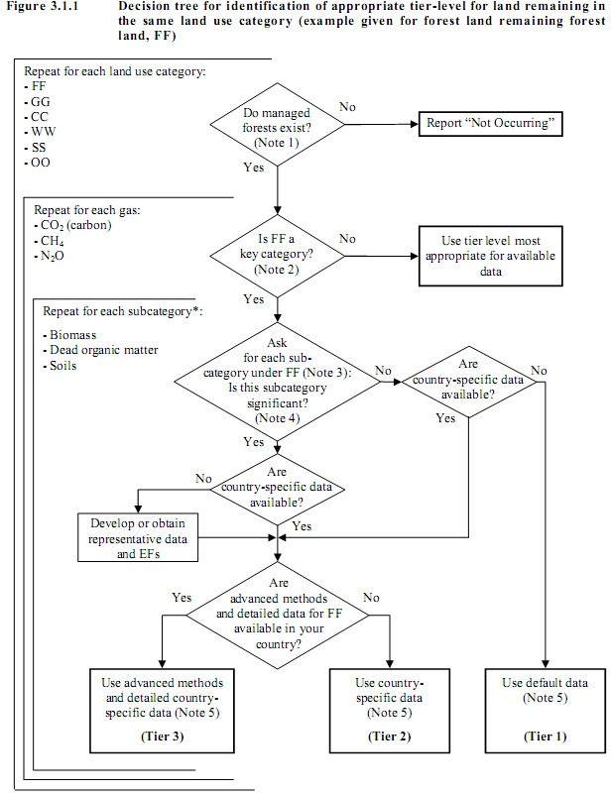

*Figure 2: Decision tree for identification of appropriate tier-level for land remaining in the same land use category (example given for forest land remaining as forest land; also called FF).*

The IPCC provide a set of computer-based tools to guide individual in country reporting of GHG emissions. These include simple MS EXCEL templates that guide users through the reporting process.

Load up the XLS file ***3C1c_Biomass Burning GL.xls*** into MS Excel to see one example of this type of template for GHG emissions from burning in grassland. You can see cells for all the

parameters contained within the standard emissions equation (Equation 1) quoted above (Columns D, E and F). Columns I, J, K and L indicate that these individual terms should be multiplied together to obtain the final emissions estimates from fire, again as expressed in Equation 1 above.

This rather simple process is the basis for the reporting of GHG Emissions from Land Use, Land- Use Change and Forestry, but how are the values for the parameters obtained?

Look at the **IPCC Annex document Anx_3A_1_Data_Tables.pdf** and you will find on pages

3.179 – 3.181 the information necessary for ascribing appropriate values to the B, C and D parameters of the above equation as a function of land cover and landuse. Take a look at some of the values for the parameters, and see by what magnitude they vary. Do they look realistic – for example compare values for forest and grassland categories?

The final piece of information - on burned area – usually comes from remote sensing. The remainder of the practical will examine this data source.

# Examining Remote Sensing Data on Biomass Burning

You are going to use a piece of professional data analysis software called **ENVI**; the “***Environment for Visualizing Images***” to examine these data. It is a widely used computer package – that is highly customizable and able to cope with many types of information.

Load up ENVI from the *Start button* or by clicking on the *desktop icon.*

# Active Fire Data

These are essentially records of where a fire was identified to be actively burning at the time the image data were collected, with the detection based on infrared radiant “heat” signatures. **Advantages** of this type of data is that it operates day and night, is very sensitive to even rather small (sub-pixel) sized fires, and that it can detect the presence of a fire in real-time for use e.g. in forecasting of pollution plumes. **Disadvantages** are that clouds mask active fires from view, and if the fire is not capable of being “seen” by the sensor when it is actually burning (due to cloud-cover or just that it is extinguished before the satellite overpass) then it will not be present in the active fire record.

Use *File/Open Image File* to load the file ***200909021445.img*** - this is a Meteosat SEVIRI full disk image taken on 2 Sept 2009 at 14:45 UTC – close to the peak of the daytime fire activity during the

southern African dry season. Meteosat is a geostationary satellite that views the entire Earth disk (Africa, Europe and part of South America) every 15 minutes. You can read about Meteosat and the SEVIRI imager it carries here <http://www.esa.int/msg/pag4.html>

In the SEVIRI image you will see the *Available Bands List* appear – and it is apparent that this image subset contains only three “bands” of information (the original SEVIRI imagery actually contains 12 bands of data; but the images are very large to work with). Our subset of data contains the brightness temperature (BT) data from the SEVIRI MIR (3.8 µm) spectral channel, the brightness temperature (BT) data from the TIR (10.8 µm) spectral channel, and the brightness temperature difference between these. You should remember from the lecture that the BT is a measure of the pixels temperature, based on the amount of thermal radiation being received from it in the particular spectral channel.

Click on the *TIR_BT* band and the *“Gray Scale”* radio button and then click *“Load Band”* at the bottom of the *Available Bands List* window. You will see the Meteosat full disk TIR image appear. Move the small red box in the *Scroll window* over southern Africa – and you will see this part of the image appear in the main *Display Window* (and a zoomed version of a subsection of it appear in the *Zoom window*). Since this is a daytime image the land is warmer than the ocean (brighter in this rendition). Clouds are the coldest objects in the scene.

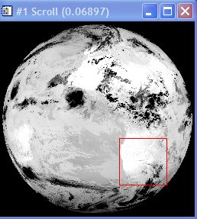

*Figure 3: Meteosat SEVIRI TIR image, with Southern Africa boxed.*

In the *Display Window* if you select *Enhance* and then *[Image] Linear 2%* a histogram “contrast” stretch will be applied to the displayed data in order to attempt to maximize the image contrast. You should be able to see patterns associated with lakes, clouds and rivers, which will be cooler than the land surface at this time. No obvious fires are apparent though.

Now click on *New Display* in the *Available Bands List* window, and use the above procedure to instead display the MIR_BT image. Histogram stretch it and you should clearly see some very bright pixels. In the Display window use *Tools/Cursor Location/Value* to display the pixel brightness temperatures. Confirm that the BT values of the fire pixels are much higher than those of the ambient background pixels, for the reasons we talked about in the lecture and that Figure 4 also indicates (i.e. that fires emit radiation much more intensely in the MIR than in the TIR spectral region; and so show up much more clearly against the background in the MIR).

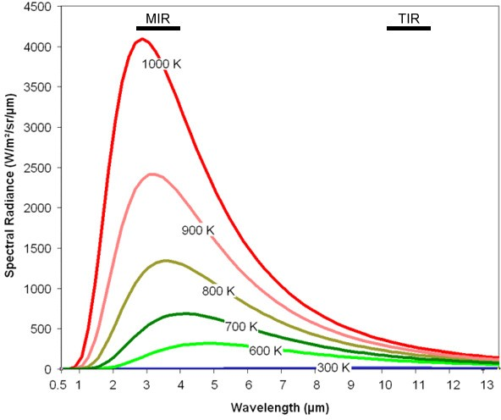

*Figure 4: Planck function plots for backbody emitters at a range of temperatures, from ambient (~ 300 K) to those in vegetation fires (~ 1000 K). The approximate wavelength range of the SEVIRI MIR (3.7 µm) and TIR (10.8 µm) spectral channels are shown. On this y-asis scale, emission at ambient wavelengths is seen to be close to the zero level, but in fact peaks around the location of the TIR spectral band (at around 10 W/m²/sr/µm). By contrast, the wavelength of peak emission from vegetation fires is seen to be located close to the MIR spectral band, where around 4000 W/m²/sr/µm are emitted.*

On the Display Window menu goto *Tools/Link/Link Displays* and “*link”* Display Windows 1 and 2. Now when you move about either of the windows the other will move to display the matching data. Confirm that pixels that clearly show fires in the MIR spectral band (as a high BT pixel value – here displayed as a “bright” pixel) in general do not show a very strong “fire” signal in the TIR spectral band. You might want to load the *BT Difference image* (which record the BT difference between the MIR BT and TIR BT of a pixel) to confirm this. This “diff’ image highlights the fire pixels very well, and suppresses the influence of ambient background variations due to elevation changes for example (since such elevation of landcover variations will affect the MIR and TIR BT values similarly, whereas a fire will affect the MIR value much more significantly due to its peak emission wavelength lying in that waveband; Figure 4). However, you can also see that areas of cloud cover can be a problem for fire detection algorithms – as they too have high MIR-TIR BT difference values. Cloudy pixels are usually masked out using other tests based on visible and TIR channel thresholding.

Data such as these are used to produce operational “fire products” that can be used as input into the IPCC process. Lets check the performance of the operational SEVIRI fire detection algorithm – used at the EUMETSAT Land Satellite Applications Facility identify active fire pixels and measure their emitted power (you can read the product details at <http://landsaf.meteo.pt/> and click on “Fire Radiative Power – Pixel”.

We also have a vector (shapefile) that shows the locations of all the active fire pixels detected by the automated fire detection scheme in this imaging slot. We can view this now and compare it to the MIR BT data. First, in ENVI, *close* all the display windows apart from Display 1 – which should still be showing the MIR BT data.

On the Display Window Menu use *Overlay/Vectors* and then *File/Open Vector File* to open the Shape File: **HDF5_LSASAF_MSG_FRP-PIXEL-ListProduct_SAfr_200909021445.shp**

[You will need to change the “type of file” to *“Shapefile (*.shp)”* in the open file dialogue window]. Just click OK to accept all the defaults in the Vector Import dialogue window.

Click the *Current Layer* colour square to change the colour of the vector points to another colour that is easier to see (e.g. red) and then press *Apply*. Now click “off’ in the top right of the Vector Parameters window so you can scroll around the image window.

Confirm to yourself that the fire pixel locations are reliably detected by the active fire detection algorithm used in the LandSAF FRP Pixel product. This is most clearly done using the Zoom Window – where you can click on the + and – symbols to zoom in and out. You should find that the location of the detected fire pixels match well with the pixels showing increased MIR brightness temperatures. However, you might quite easily be able to find some pixels where the MIR BT signature looks like the pixel might contain a fire, but where the fire detection algorithm has not detected one (i.e. a likely omission error). Errors of commission (i.e. false detections) should be quite low though (< 10%).

Timeseries of active fire data like this can be used to estimate the area burned for input into the IPCC GHG Emissions estimation procedure (essentially by calculating the number of discrete fire pixels that occur in an area of interest). However, in these types of grassland-dominated or woodland environments a better type of product from which to estimate burned area is likely to be one based on detection of reflectance changes due to burning. We will examine this type of product next.

# ATSR World Fire Atlas (WFA) Long-Term Active Fire Data Record

The ATSR series of polar orbiting satellite sensors has delivered the longest-running data record of active fire detections currently available, starting from 1995 to the present period. The record is termed the World Fire Atlas (WFA) and is derived via a very simple thresholding algorithm applied to nighttime observations made in the ASTR MIR spectral band. Though fires are generally much more active by day than by night, these observations do provide a reasonable data source from which the seasonality and interannual variability of fire in any particular region can be determined. Another positive point is that the WFA is very simple to use, and there is a web interface that is very easily understood ([http://wfaa-dat.esrin.esa.int/).](http://wfaa-dat.esrin.esa.int/)) A user guide for this can be found at <http://wfaa-dat.esrin.esa.int/wfa_user_guide.pdf> and the web interface allows selection of the data from a single county, graphing of total annual active fire counts for that country over many years, examination of a single year in terms of monthly active fire count (to examine seasonality) and also export of ascii data containing the hotspot locations and dates. A paper using the WFA data can be found at <http://www.atmos-chem-phys.net/8/1911/2008/acp-8-1911-2008.html>and a paper on some of the issues to take into consideration with this dataset is http://www.atmos-chem- phys.org/6/1409/2006/acp-6-1409-2006.html . Take some time now to select a fire-affected country and examine the different possibilities for display of the ATSR WFA data record. First select the continent and country, then on the upper left hand side the date range and lower left hand side the output format. Finally press “Search” to display the data record.

# Burned Area Products

These are essentially records of where a fire was identified to have burned the landscape, with the detection based on changes in the reflectance (or “colour”) of the surface. In the lecture we saw that when an area of vegetation burns, its spectral reflectance generally falls since the vegetation is partly removed and the ground surface becomes at least partly covered by a layer of dark char. The advantages and disadvantages of this type of product are in some ways opposite to the active fire products you examined previously. **Advantages** of burned area products are primarily that they are a direct estimate of the actually burned area for use in Equation 1, and that secondly if clouds mask the surface from view during a particular satellite overpass, then it is quite likely that the burned area can still be detected on the next overpass (in fact in some environments it can be detected for many weeks or even months). **Disadvantages** are that they are often not very sensitive to small burns, and that since they only respond to changes in surface reflectance caused by the fire – they only really provide useful data after the fire has happened (so do not provide “real time” information). They also only provide usable data during daytime overpasses.

As we discussed in the lecture, the sore of spectral reflectance signature change associated with burning can be quite reliably detected by sophisticated algorithms trained to look for such temporal changes. In Figure 5 below, you can see the “darker” colour signature of the imaged burned area, and in the spectral reflectance time series you can see how the pixel that burns around day 274 experiences a sharp decrease in reflectance ((open triangles) compared to the pixel that does not (closed triangles).

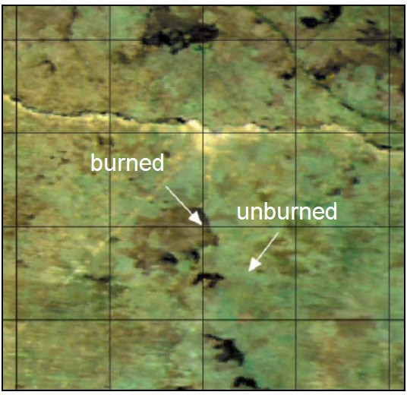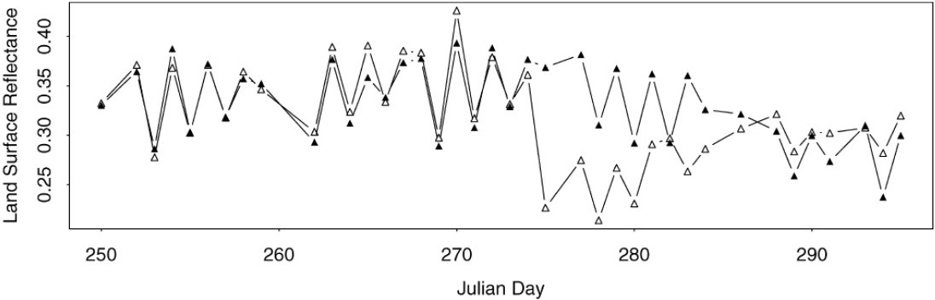

*Figure 5: Planck function plots for backbody emitters at a range of temperatures, from ambient (~ 300 K) to those in vegetation fires (~ 1000 K). The approximate wavelength range of the SEVIRI MIR (3.7 µm) and TIR (10.8 µm) spectral channels are shown. On this y-asis scale, emission at*

One of the most commonly used burned area products is that produced from the MODIS sensor. You can read some background about MODIS at <http://afis.meraka.org.za/wamis/modis_basics.php>

The MODIS burned area product (MCD45) is a “Level 3” gridded 500m product, meaning that it represents heavily processed information produced from MODIS data via use of a dedicated set of algorithms, rather than “raw” MODIS data. It is produced in the standard MODIS *Land Tile* format in sinusoidal projection. Each tile has fixed earth-location, as shown in the first figure in this practical handout, and covers an area of approximately 1200 x 1200 km (10° x 10° at the equator). The product defines for each 500 m pixel within the tile the approximate day of burning – identified via changes in spectral reflectance such as that shown in Figure 5. The MCD45 product is obtained from processing combined MODIS-TERRA and MODIS-AQUA 500m land surface reflectance data, and is stored in Hierarchical Data Format (HDF) – a common data format used for science datasets.

More info: <http://modis-fire.umd.edu/MCD45A1.asp>

User guide: <http://modis-fire.umd.edu/documents/MODIS_Burned_Area_Users_Guide_1.1.pdf>

To explore use of the MODIS MCD45 Burned Area product product, have ENVI running and Click on *File – Open External File – Generic Format – HDF.* This opens HDF files (i.e. in this case the individual MODIS MCD45 tile data of burned area).

The HDF format file supplied contains the following datasets relating to burned area in one file. Select the *“Burn Date”* dataset and click OK. This will display the estimated date of the burn (i.e. in the Figure 5 example day 274) data as an item in the *Available Bands* window. From here it can be displayed in an image window.

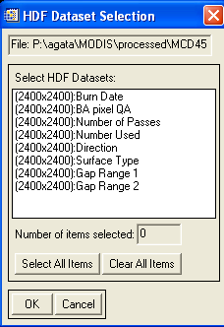

*Figure 6: The HDF datasets contained in the example MCD45 file provided.*

Display the *Burn Date* dataset with ENVI as you did with the previous Meteosat SEVIRI imagery. You should see it as an apparent binary (black/white) tile of data covering part of southern Africa - with ocean to the west of the scene, and some lakes mainly in the south.

Use the *Tools/Cursor Location/Value* command from the *Display Window* menu to check the digital number (DN) given to these pixels, you should see it as a very large value (10000 or 9999) whereas the background land surface is given a value of zero. Actually this dataset contains the map of burned area, where each pixel is coded with the day of the year on which it was detected as being burnt (so a value from 1 to 365) but you just cannot see it as displayed here since the contrast stretch automatically being applied to the data is essentially making all these pixels appear black on the computer monitor. This is because the contrast has to encompass the display of numbers from 0 to 10000.

We can use some simple mathematical operations to deal with this problem. On the ENVI main menu goto *Basic Tools* and then *Band Math*. In the “*enter the expression”* dialogue box type in the mathematical expression **(b1 lt 400)*b1** [where “lt” stands for “less than”]

In this expression, b1 represents the variable (band of data) you are going to process and the expression essentially says:

*“Take the band of data (b1) and where a pixel has a value of less than 400 (i.e. a burnt or a non- burned land pixel, rather than a lake or ocean pixel) give it the value of 1, otherwise give it a value of 0. Then multiply this by the original data values.”*

Essentially then this should provide a dataset very similar to the original data, but with the 9999 and 10000 values removed.

Click OK and select the *“Burn Date”* as the variable *b1* and choose to *“Output the result to Memory”* (rather than “File”). The output from this operation should appear in the *Available Bands List*. Now *Display* it in a new display window.

The image will very likely initially appear black, but if you select *Enhance-Histogram* and then *[Scroll] Linear 2%* you should see a large number of burned areas appear. Move the red box around the *Scroll Window* until the *Display Window* shows one of the areas most affected by burning. Each pixel here represents an area of around 500 m x 500 m on the ground – so these burns are rather large, and there are very many of them. You can see just what a large proportion of this environment burns each year.

Each burnt pixel is coded by the day it burnt. You can best display this using a *colour palette*. Onthe display window goto *Tools/Colour Mapping/Envi Colour Tables*. Scroll down to the end of the *Colour Table* list to find the *Rainbow + White* colour table and highlight it. Then move the *“stretch bottom”* slider to the right - this controls how the values in the file are translated to colours in the colour table. You should be able to adjust the display so that you can see the different dates on which each pixel burnt by its displayed colour – and some of the larger burns you can see the daily progression of the burn as the fire evolved.

Now load the EXCEL file: **ModisBurnedArea_by_country_landuse_vegetation.xls** this stores the amount of burned land detected by the MODIS burned area product by African country, and also by vegetation type and landuse – exactly the information that the IPCC GHG Emissions Inventory process that we examined earlier requires.

Load up the **“SummarybyCountry”** worksheet in EXCEL and look at the country of **Angola** – the location of the MODIS Burned Area product you were just examining. You can see that Angola has a land area of almost 2.8 million km² and that on average 27% of it burns every year - equivalent to just over a 4 year mean fire return interval. Going to the **summary_byCountryVegLanduse** worksheet and you can see that a landuse/landcover map has been used with a GIS to break down this total burned area into different vegetation classes (grassland, forest etc) and different landuse types (cultivated lands, protected areas etc). This is the last piece of information required by the different stages of the IPCC Inventory process – and now the emissions inventory equation can be completely parameterised for each land use class.

Should you wish to examine or use more “Burned Area” data, the best way to obtain these MODIS Burned Area products is listed at <http://modis-fire.umd.edu/index.html> (click on Burned Area Products at top, and then “Get Data” at left). Early generations of the MCD45 product had provisional product maturity status, but this is common and the validation and intercomparison exercises are ongoing and the product performance is increasing with each new version.

For now we will see how to get some other forms of remotely sensed fire data – from a system called FIRMS.

# Accessing Other Remote Sensing Fire Information

The Fire Information for Resource Management System (**FIRMS**): <http://maps.geog.umd.edu/firms/> provides information on global fire activity for use in resource assessment. Soon these data should also be available via the FAO Global Fire Information Management System. For more information see: <http://maps.geog.umd.edu/firms/readmore.htm>

For now we can concentrate on use of the data from FIRMS. These systems offer a variety of downloadable data on fire, mostly again taken from the MODIS sensor and concentrating on “active fire” rather than “burned area” datasets.

The MODIS active fire products are available in a variety of easy-to-use data formats. The data themselves are similar to the Meteosat SEVIRI active fire data you used earlier, albeit from observations made every ~ 6 hrs from MODIS’ polar orbit rather than every 15 minutes from Meteosats geostationary orbit. The formats include:

* + - 1. Shapefiles of fire locations from the past 48 hours and past 7 days
      2. Daily text files of fire locations via ftp site for the past two months
      3. Daily/weekly/near real-time CSV/text files of fire locations via email alerts

Another site where a version of these same data are available via a quick web interface is called the Web Fire Mapper.

Before examining the FIRMS data, take a look at the Web Fire Mapper at: <http://firefly.geog.umd.edu/firemap/> and try to find on which continents a large amount of fire activity is taking place currently (this will depend primarily on the time of year, since fire activity has a marked seasonality related to climate). Whilst you search, select “Blue Marble” as the background image (this is a global colour composite produced from MODIS imagery that quite nicely shows the patterns of vegetation over the land surface). This will provide you with an idea of the vegetation conditions, for example with “brown/bare” areas having insufficient fuel to carry a strong fire.

Once you have found a suitable location of fire activity, try accessing the FIRMS system to download some vector (**shapefiles)** relevant to these fire locations. You can do so for the past 24 hrs, 48 hrs or 7 days and can examine the data in ENVI as you did previously for the Meteosat SEVIRI-derived active fire shapefiles

**Goto** <http://maps.geog.umd.edu/firms/shapes.htm>and select the area you have identified as being fire-affected at the present time. Select the 24 hrs, 48 hrs or 7 day product to *download* the ZIP file - and then extract the contents of the ZIP file to your temporary working directory.

Now goto *ENVI* once again and use *File/Open Vector File* (with file types set to **Shapefile**). Select the **\*.shp** file you just unzipped and click OK to accept all the default *Vector Parameters*. You should see vector points (**white crosses)** appear at locations where fires were identified by MODIS to be burning within the period you selected. If you chose to *download the text version* you could check the lat/long location of these fires in a *text editor* or *spreadsheet*. However, we can get an idea where they are by using a vector file of *Country Boundaries*.

In the *Available Vectors List* window, goto *Options* and *Create World Boundaries*. Select *Politcal (Low Res)* and *Coastlines (Low Res)* – which are numbers 4 and 5 in the list – and also select the output to *“memory”* rather than to a file.

Click OK. Then choose to display all the layers you have made by selecting *“Select All Layers”* in the *Available Vectors List* – and then *Load Selected*.

Choose to load these in a new *Vector Window*. You will see the world map, together with the fires.

Now in the menu of this *Vector Window* goto *Options, Select Active Layer* and ensure the *Active Fire layer* is selected, rather than the world map. Then goto *Edit* and *View/Edit/Query Attributes* to see a list of the active fire detections and their various parameters (location, time, signal strength etc). These are the detailed information on each fire detection, that is also available in the text file version of the same dataset if you prefer.

Finally, there is also a **Google Earth KML** version of the same data available from FIRMS: [http://maps.geog.umd.edu/firms/kml.htm.](http://maps.geog.umd.edu/firms/kml.htm)

KML format data of burned areas are also available, for example from the **European Forest Fire Information System (EFIS),** which can be found at [http://effis-](http://effis-/) viewer.jrc.ec.europa.eu/wmi/viewer.html

Load up the example you have been supplied with - **Greece_fires_aug09.kml** in ***Google Earth*** – it contains burned area vector format data of the 2007 Greek Fires, derived from the MODIS MCD45 Burned Area product. Compare it visually with the original MODIS burned area product data,

shown on the image of Greece below:

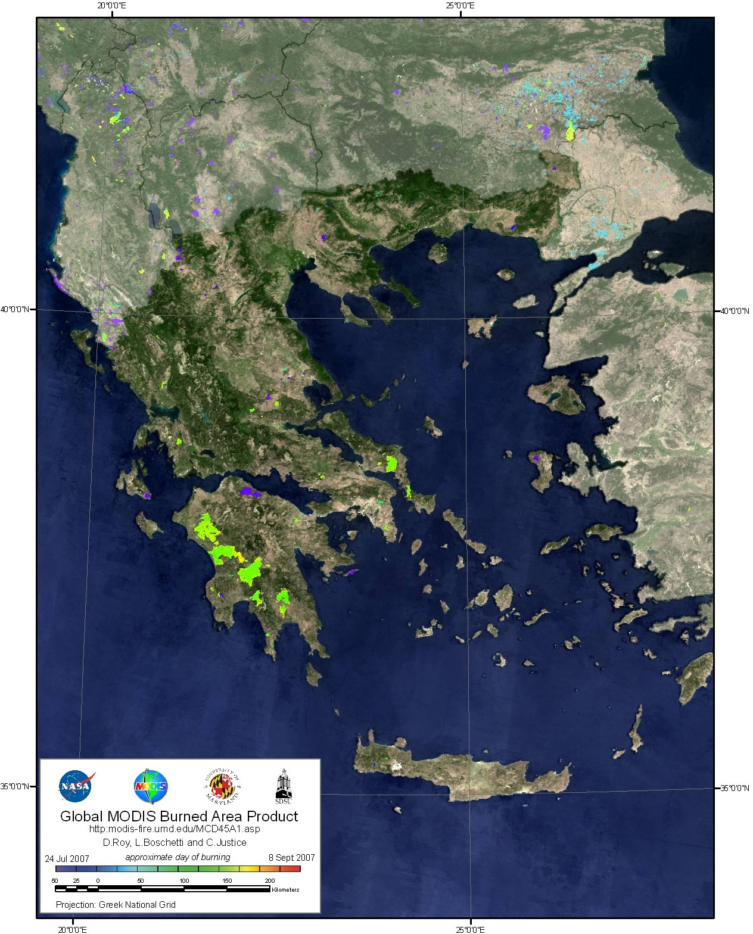

*Figure 7: Burned area map of the 2007 Greek fires, derived from the MODIS Burned Area Product (MCD45). Figure taken from Boschetti et al (2008).*

# References:

Boschetti, Luigi, Roy, David, Barbosa, Paulo, Boca, Roberto and Justice, Chris (2008) A MODIS assessment of the summer 2007 extent burned in Greece, *International Journal of Remote Sensing*, 29, 2433 – 2436.